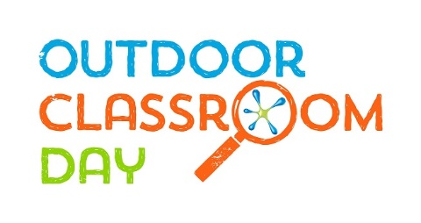
Outdoor Classroom Day
Media Pack

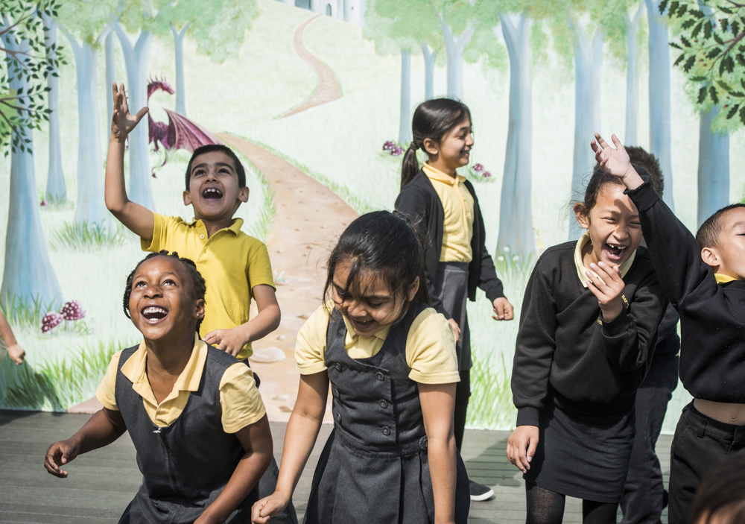

“Academic research shows that active play is the natural and primary way that children learn.”
Sir Ken Robinson, leading expert in education, creativity and human development.

Contents
1. Campaign overview
2. Biographies
3. FAQs
4. Images
5. Contact details
Campaign overview
Outdoor Classroom Day is a global campaign to inspire and celebrate outdoor learning and play. On the day, thousands of schools around the world take lessons outside and prioritise playtime. As well as having fun, they will show how important and easy it is to give children more time outdoors.
So that schools can participate on a day that fits with their climate and term times, the global campaign has two dates each year – check the website for future dates: www.outdoorclassroomday.com
When teachers take learning outdoors they report some powerful impacts: Children’s behaviour improves, whole classes are excited to learn, and individuals who feel inhibited by the curriculum often thrive in an outdoor environment.
When adults think back to their own happiest memories of childhood, they frequently recall the joy of playing outdoors. Play is not only central to children’s enjoyment of childhood, but teaches critical life skills such as problem-solving, teamwork and creativity.
The campaign is about more than just one day; it is a catalyst to inspire more time outdoors every day, both at school and at home. To achieve this, the campaign has three aims: Outdoor learning is part of every school day for every child; Every child has great recess/playtime at school every day for at least 60 minutes, with the longer term aim of 90 minutes; Schools act as advocates for more time outdoors, so that outdoor play becomes part of every child’s everyday life.
Everyone can do something to make sure children experience the benefits of being outdoors. Parents can encourage their child’s school to get involved and take steps towards more time outdoors at home. Businesses can become campaign partners and think about how they can support local projects that support children’s play. Anyone who cares about childhood can help spread the word about the importance of outdoor play and learning.
Whatever you do, join the movement today: www.outdoorclassroomday.com
The global Outdoor Classroom Day is led by Semble (formerly Project Dirt and a founding member of the campaign), in partnership with Unilever as part of their Dirt is Good movement. The COUNTRY campaign is led by NGO, with support from UNILEVER TEAM.
Biographies
Nick Gardner, Co-Founder of Semble
Nick Gardner is passionate about using social media for good. Having started out his career as a youth and community worker and then a ski instructor, he knuckled down to building a career in economic development and regeneration. Evaluating major government and Lottery programmes of community investment led him to set up a social networking platform to promote and resource community projects. With over 3,000 projects, Semble is now the UK’s largest online network of community projects. Semble was selected by the Sustainable Development Commission as a ‘Breakthrough Idea for the 21st Century’; selected as a Deloitte ‘Social Innovation Pioneer’; and a NESTA ‘Innovation in Giving’ award winner.
The Semble team runs community investment and corporate volunteering campaigns for clients. Nick and his team have grown the company over the last four years with major private sector clients including Timberland, Greggs and Carling. Semble is a founding member of the Outdoor Classroom Day campaign and in 2016 partnered with Unilever to grow the movement and take it global. Continuing their commitment to getting children outdoors and to green issues, the team partnered with Iceland in 2019 to deliver the Backyard Nature campaign. Nick (along with co-founder Mark) was identified by George Monbiot in the Guardian as one of the most influential green pioneers in the UK.
Add your headteacher’s biography here.
FAQs
How did Outdoor Classroom Day start?
In 2011, at the launch of Tim Gill’s Sowing the Seeds report, a group of educators and environmentalists discussed how schools in particular could address the issues that stop children getting outdoors. Their solution was a new campaign they called Empty Classroom Day.
In 2012 a handful of schools in London, England, got involved. By 2015, over 600 schools in 15 countries were involved. As the campaign grew, the volunteers who were running it recognised the need for dedicated investment. So, in 2016, Semble partnered with Unilever’s Dirt is Good team to grow the movement and take it global.
Following consultation with school leaders, play experts and NGOs around the world, the global campaign became Outdoor Classroom Day. There are currently dedicated campaigns running in 13 countries, in addition to a much wider network of schools getting involved in more than 110 countries worldwide!
The campaign’s founder and advisory board member, Anna Portch, continues to be involved in every campaign day.
Who is behind Outdoor Classroom Day?
The global Outdoor Classroom Day is led by Semble, supported by Unilever as part of their Dirt is Good movement. Semble is a social enterprise that connects and resources grassroots community projects, and a founding partner of the original campaign. Unilever is backing Outdoor Classroom Day as part of their core purpose to help parents everywhere make sure that real play is part of every child’s day.
Semble works with respected environmental and educational NGOs around the world to deliver locally relevant campaigns, from Finland to Brazil. Many of these NGOs are supported by local Dirt is Good teams, and the experts they work with, to broaden their reach. But really the campaign is delivered on the ground by teachers, parents and supporters! None of us can do this alone.
Is Outdoor Classroom Day just one day?
Outdoor Classroom Day is about more than just one day, it’s a global campaign to inspire and celebrate outdoor learning and play every day. By getting involved in the annual celebrations, teachers help send a message to the world that time outdoors every day is important for every child. They also help to achieve these longer-term shared goals:
- Outdoor learning is part of every school day for every child.
- Every child has great recess/playtime at school every day for at least 60 minutes, with the longer-term aim of 90 minutes.
- Schools act as advocates for more time outdoors, so that outdoor play becomes part of every child’s everyday life.
What are the benefits for taking children outdoors to play and learn?
When teachers take learning outdoors they report some powerful impacts: Children’s behaviour improves, whole classes are excited to learn, and individuals who feel inhibited by the curriculum often thrive in an outdoor environment.
When adults think back to their own happiest memories of childhood, they frequently recall the joy of playing outdoors. Play is not only central to children’s enjoyment of childhood, but teaches critical life skills such as problem-solving, teamwork and creativity.
Find out more about the benefits of outdoor play and learning and the difference that Outdoor Classroom Day is making in schools around the world in the Muddy Hands and Playtime Matters reports.
Does the Government back outdoor lessons?
In countries including Australia, Canada and the UK, most state or regional governments formally recognise outdoor learning and break time as beneficial. But children are still by no means learning outdoors every day or playing outdoors; either for the minimum hour recommended for physical activity, or for the 25% of school time that some psychological research on mental wellbeing suggests is optimal.
Is it free for teachers to get involved?
Yes! Registration is free and there is even a whole library of free resources such as outdoor lesson plans for teachers to access on the Outdoor Classroom Day website.
What do teachers get when they sign up?
Teachers get to put their school on the Outdoor Classroom Day map and become part of the global movement for more time outdoors every day. If they opt in, they receive regular campaign emails with resources, inspiration and information to help them get outdoors on the day and all year round.
Should teachers sign up for every campaign day?
Yes! The more schools that get involved in the campaign each year, the more noise we make for our longer-term shared goal that outdoor play and learning are made a key part of the school day.
How can non-teachers get involved?
They can spend some time outdoors on the day and share their experiences on social media using #OutdoorClassroomDay!
Nurseries, kindergartens, after-school groups, play organisations youth groups, or even universities can sign up as a school and add a note about who they are in the ‘What are your plans for the day?’ box.
Parents of school-aged children can use the ‘letter to parents’ on the campaign website to ask their child’s school to sign up. They could take their children outside after school on the day as well and sign up via the parent tab for additional information and inspiration.
Individuals who work for organisations that believe in the power of outdoor learning and play can get involved by helping to spread the word about the campaign. The ‘supporter pack’ on the campaign website provides ideas and resources.
Images
Visit the Outdoor Classroom Day media image library for a selection of photos you have permission to use with your story. Please note that these images can only be used to promote Outdoor Classroom Day. ADD LINKS/ATTACH PHOTOS FROM YOUR SCHOOL IF YOU HAVE A SELECION WITH PERMISSION TO USE FOR MEDIA WORK.
Contact
For further information and to arrange an interview with a spokesperson, please contact ADD MEDIA LEAD NAME AND CONTACT DETAILS HERE. To arrange an interview with Nick Gardner, please contact Claire Colvine on claire@outdoorclassroomday.com.

